**Website Wireframe Designs**

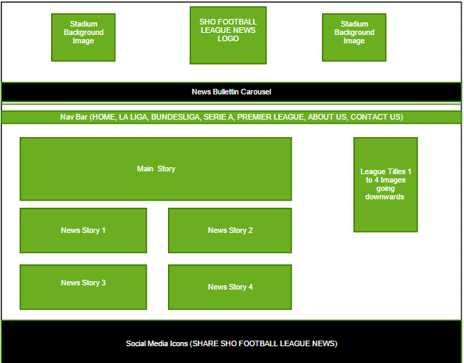**Home Page Design**

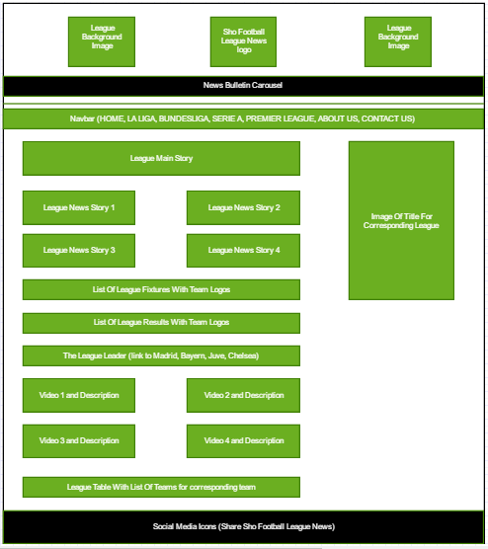**League Pages Design (LA LIGA, BUNDESLIGA, SERIE A, PREMIER LEAGUE)**

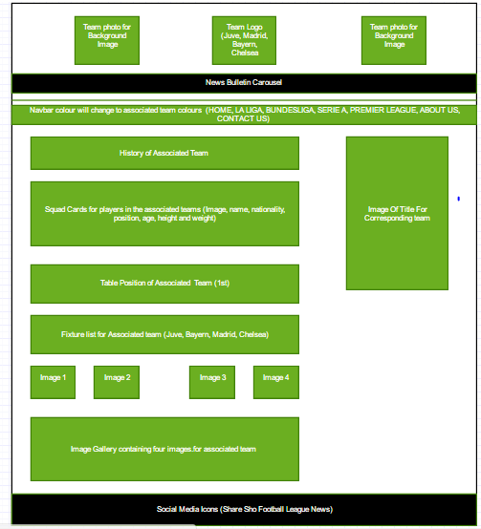**League Leaders Design (BAYERN, CHELSEA, MADRID, JUVE)**

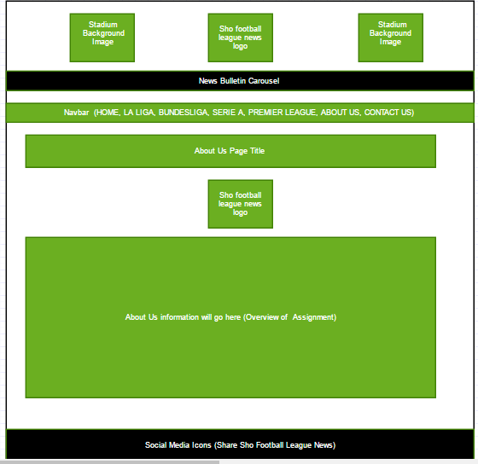**About Us Page Design**

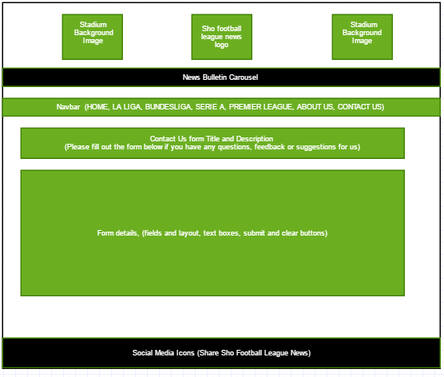**Contact Us Form**

**Responsive Nav Bar Design**

